Effects of Spanish Rule in Florida
Grade 4
The following question is based on the accompanying documents (1-5). It is designed to test your ability to examine and interpret the meaning of the documents. Then you will write a final essay which uses important information from the documents you have analyzed.
Historical Background:
In 1492, Christopher Columbus sailed across the Atlantic Ocean from Europe and landed in the Americas. By the 1600s, the Spanish, British, French, and Dutch had explored the Atlantic Coast of what is now the United States. Spain claimed Florida in 1513 and ruled it for over 280 years. There were many effects of Spanish colonial rule in Florida.
Task:
For Part A, read each document carefully and answer the question or questions after each document. Then read the directions for Part B and write your essay.
For Part B, use your answers from Part A, information from the documents, and your knowledge of social studies to write a well-organized essay. In the essay you should:
Discuss the effects of Spanish rule in Florida.
Directions:

- Read the task. Do you understand it?
- Ask yourself: “What do I already know about the Spanish arrival, exploration, and colonization of Florida? How would I answer the question, even if I could not look at the documents?”
- Now look at the documents. Study each one and highlight any information that will help you answer the question. Ask yourself: “How does this help me to answer the question?”
- Each document is followed by a question(s). Write an answer to each of these questions in the blank that follows it.
- When you are finished studying all the documents, go on to Part B. Follow the directions and write your essay.

Document 1:
Since waterways were important highways in colonial times, many of the first settlements were established on coasts.
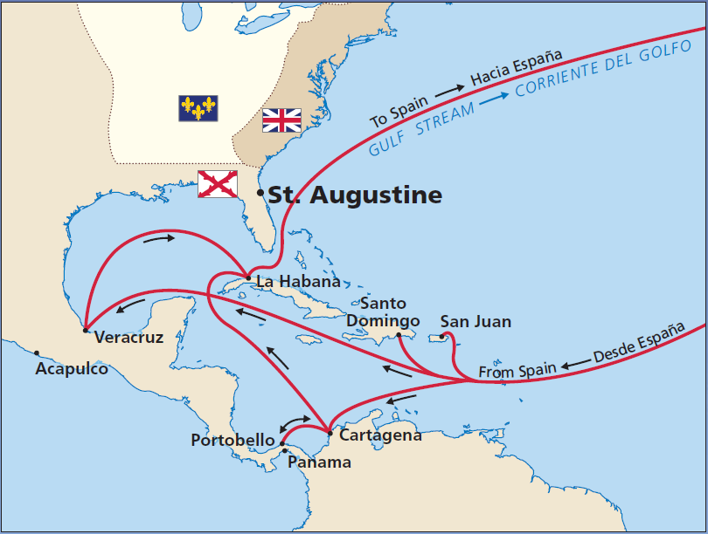
Source: National Park Service

- According to the document, what settlement did the Spanish establish in Florida?
Possible answers:
- St. Augustine

Document 2:
The following was written in 1565 when the Spanish arrived in St. Augustine, Florida.
“On Saturday, the 8th, the general (Pedro Menéndez de Avilés) landed… marched up to the cross, followed by all who accompanied him, and there they kneeled and embraced the cross. A large number of Indians watched these proceedings and imitated all they saw done…
On Monday, September 24th... we saw a man approaching with loud cries. I was the first to run to him and get the news. He embraced me with transport, crying, "Victory! Victory! the French fort is ours!"
Source: Francisco Lopez de Mendoza Grajalas: The Founding of St. Augustine, 1565 (adapted)

- Based on the document’s source, who’s point of view is this?

Possible answers:
- Francisco Lopez de Mendoza Grajalas wrote this document.
- This is from the Spanish point of view.
- Based on the document, describe one result of the Spanish arrival in St. Augustine, Florida.
Possible answers:
- The Spanish brought their religion with them.
- The Spanish and Native Americans met.
- The Spanish took over the French fort.
- Pedro Menéndez landed in St. Augustine.

Document 3:

There were nine earthen and wooden forts in St. Augustine before a stone fort was built.
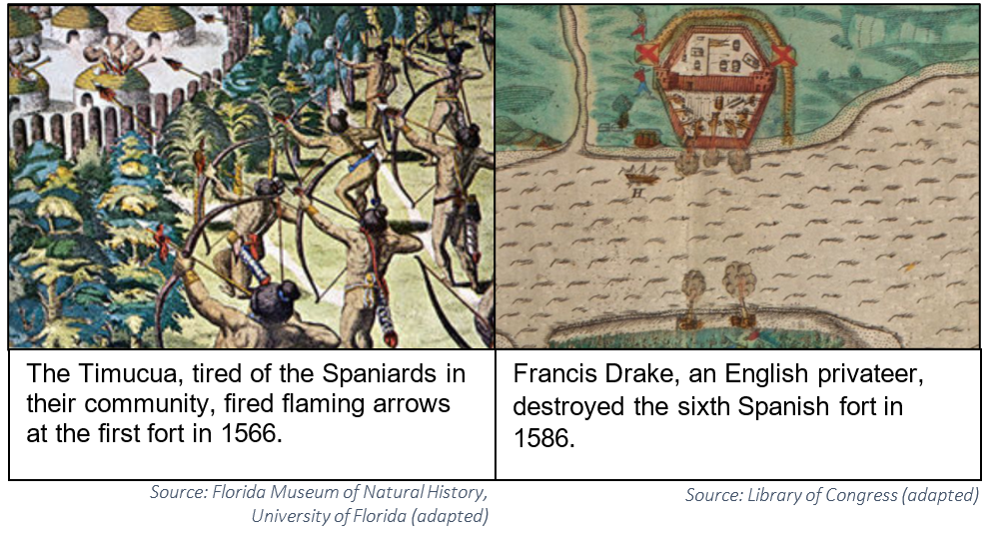

- Based on the documents, describe one conflict or problem the Spanish encountered.
Possible answers:
- The Timucua attacked the Spanish fort.
- Francis Drake attacked the Spanish fort.
- The Spanish built nine forts that were destroyed.
- The Spanish had to build a stone fort, because their enemies kept destroying their wooden forts.

Document 4:
Spaniards, free and enslaved Africans, European prisoners, and Timucua, Apalachee, and Guale natives built the Castillo de San Marcos out of coquina stone in 1672-1695. Although it has been attacked several times, the fort has never been destroyed or defeated.
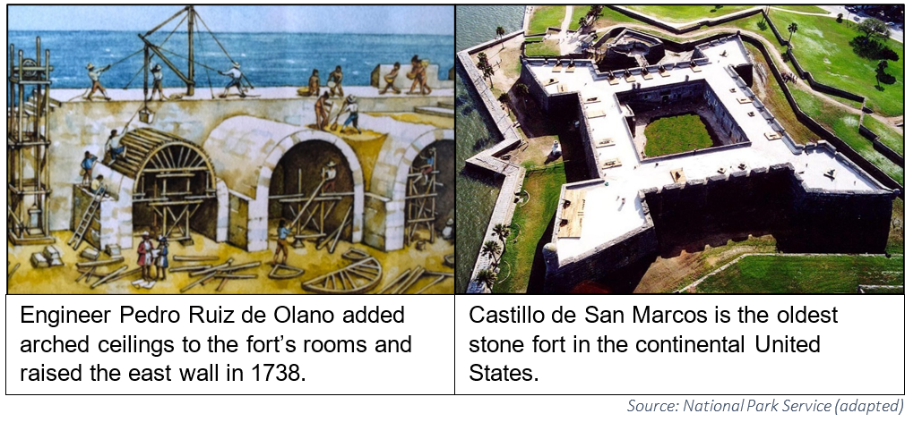
- Based on these documents, who built the Castillo de San Marcos?

Possible answers:
- The Spanish built the fort.
- Spaniards, Africans, Europeans, Timucua, Apalachee, and Guale natives built the fort.

- Based on these documents, why is the Castillo de San Marcos important?

Possible answers:
- The Castillo is the oldest stone fort in the continental United States
- The Castillo has never been destroyed or defeated.
- The Castillo is built out of coquina.
- The Castillo is important, because of its design (it’s shaped like a star, it’s made of stone, it’s rooms are arched, etc.).
Document 5:

The population in 1763 in St. Augustine, Florida.
Class | Population
Soldiers and their families | 1,916
Catalan fusiliers (soldiers who use flintlock muskets) and their families | 161
Canary Island families | 425
German Catholic families | 26
Christian Native Americans | 89
Free people of African ancestry | 23
Free people of mixed ancestry (European, African, Native American) | 76
Enslaved people of African ancestry | 309
Convict laborers | 38
TOTAL | 3,063
Source: Florida Museum of Natural History, University of Florida

- Based on the document, what was the total population in St. Augustine in 1763?
Possible answers:
- The population was 3,063 or the population was over 3,000.
- Based on the document, were the people of St. Augustine diverse? Justify your answer using the information from the chart.

Possible answers:
- Yes, because the chart shows nine different groups.
- Yes, because the chart shows soldiers, families, Germans, Africans, Native Americans, Europeans, etc.
- Yes, because the chart shows different workers, religions, nationalities, ethnicities, etc.
Part B:
Directions: Using the documents, your answers to the questions in Part A, and your knowledge of social studies, write a well-organized essay about the effects or results of Spanish rule in Florida during the colonial period.

In your essay, remember to:
- Discuss the effects of Spanish rule in Florida.
- Include an introduction, body, and a conclusion.
- Include details, examples, or reasons to develop your ideas.
- Use specific details from at least three documents in Part A.
- Develop your essay using correct grammar, punctuation, and spelling.

- Big Ideas from Doc. 1-5 that support that there were many effects of Spanish rule:
- Spanish established St. Augustine, La Habana, San Juan, and other settlements.

- The Spanish met Native Americans, brought their religion with them, and defeated the French in St. Augustine.
- Spanish had conflict or problems with the Timucua, Francis Drake, and others.
- The Spanish built the Castillo de San Marcos, the oldest fort in the continental U.S.
- Many diverse people lived in St. Augustine.
- Background from class that supports that there were many effects of Spanish rule:
- Examples of other Spanish explorations and settlements (e.g. Ponce de León, Hernando de Soto, Tristan de Luna, Pensacola, etc.)
- Examples of foods, animals, people, treasure, disease, etc. going back and forth between Europe and Americas (e.g., Columbian Exchange).
- Examples of how Native Americans were impacted as mission sites (e.g., Nombre de Dios, Mission San Luis, etc.) were created, diseases spread, conflict increased, soldiers married native women, etc.
- More details about the conflicts Spain had with France (e.g., Fort Caroline), England (e.g., Sieges of 1702 and 1740), and pirates (e.g., Robert Searles), etc.

- Examples of Spanish culture merging with people in the Americas to create a Latinx or Hispanic culture. Provide language, religion, family values, foods, art, clothes, etc. examples.
- Examples of other forts, towns, structures that were built and/or still exist (e.g., Fort Mose, Fort Matanzas, Old Town Fernandina, Cathedral Basilica, Historic Pensacola, etc.). Give examples of streets, towns, structures that were named after Spaniards or Catholic saints.
- Examples that there were many diverse people living in colonial Florida. (e.g., The Spanish in St. Augustine married Native Americans. There were enslaved Africans and free black citizens at Fort Mose. There were Menorcans, Irish, and other Europeans who joined the Spanish.)

- Example Essay:
After Christopher Columbus landed in the Americas, many others followed him. Spain claimed Florida in 1513 and established settlements, like St. Augustine. There were many effects of Spanish rule on the people and places where they lived.
Spanish rule affected people in many ways. When the Spanish met the Native Indians, they exchanged foods, technology, and diseases. In Document 3, the Timucua Indians attacked the Spanish fort in St. Augustine. The Spanish also fought with the French and English. In Document 2, Pedro Menendez conquered the French fort. Spanish rule also led to many different people living together in Florida. In Document 5, there are soldiers, families, and Native Americans living in St. Augustine. Fort Mose was the first free African American settlement.
The Spanish ruled many places in Florida. In Document 1, they established many settlements, like St. Augustine. St. Augustine is the oldest permanent European settlement in the continental United States. In Document 4, the Spanish built Castillo de San Marcos for protection. The fort is made from coquina and is the oldest stone fort in the United States. The Spanish named towns, streets, and forts after saints and Spaniards. The Spanish built Mission San Luis and other missions across Florida to teach their religion to the Native Americans.
There were many effects of Spanish rule in Florida. Some people are gone, like the Timucua Indians who died from diseases. Some people remain who still speak Spanish or practice the Catholic religion. Some villages where the Native Americans lived are gone. Other places remain, like St. Augustine. To learn more about the effects of Spanish rule, people today can visit some of the places they lived and forts they built.

